NEWS RELEASE

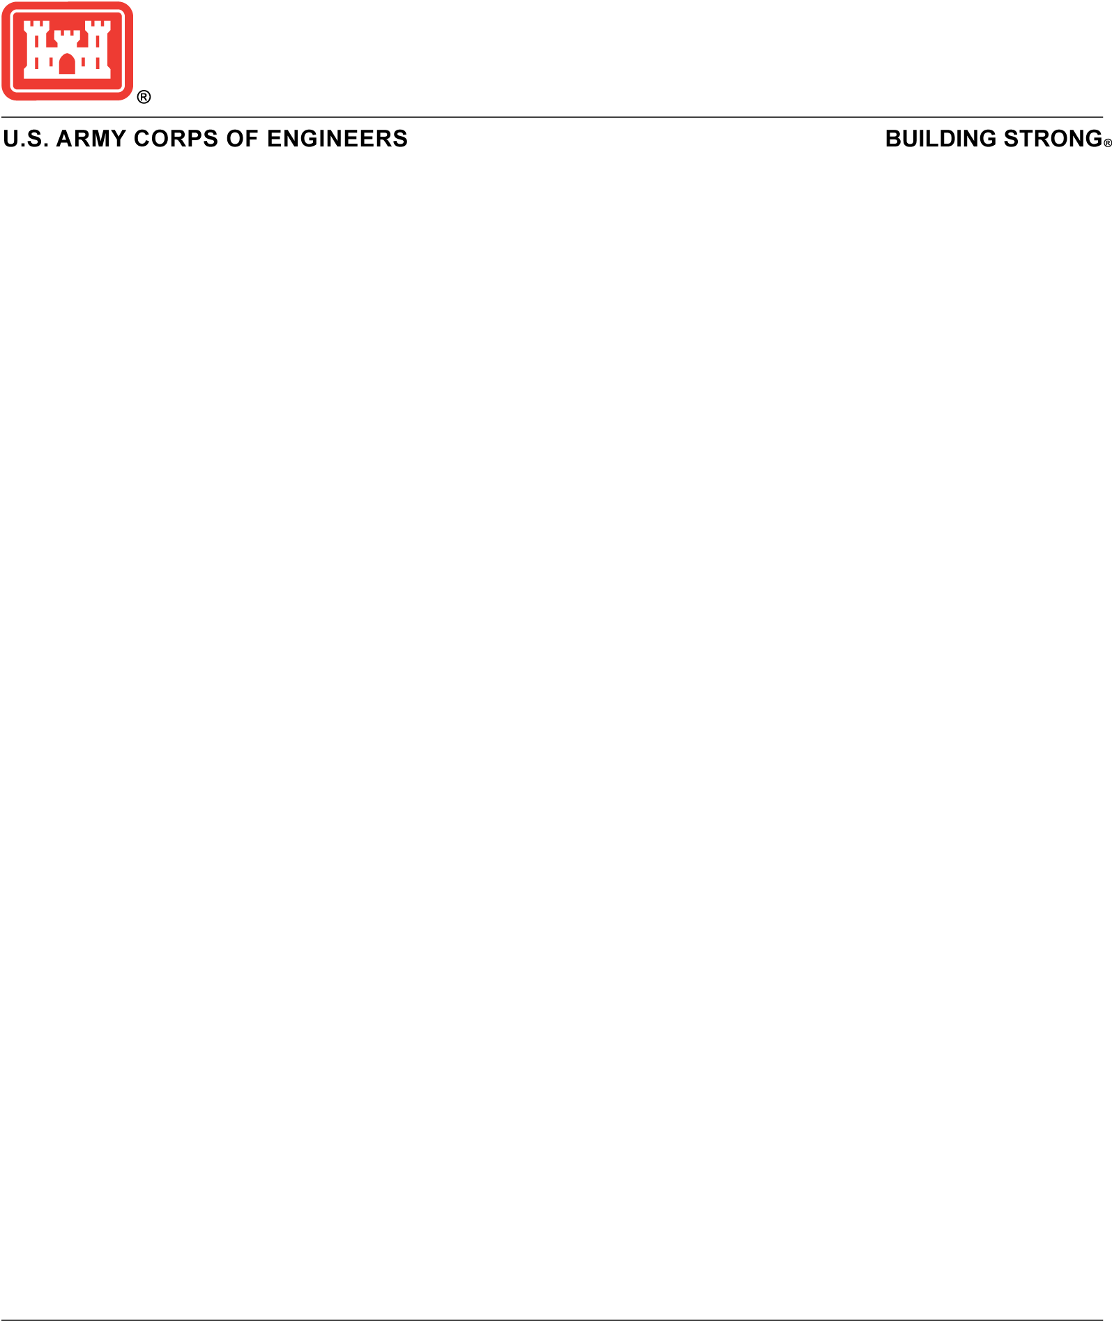

## Army Corps to share update on remediation at former DuPont Chambers Works site

PHILADELPHIA (May 9, 2025) – The U.S. Army Corps of Engineers Philadelphia District will present an update regarding the ongoing remediation at the former DuPont Chambers Works site in Deepwater, N.J. The presentation will take place at the beginning of the Salem County Commissioner’s meeting on May 21 at 4:00 p.m. at the Salem County Historic Courthouse (104 Market Street, Salem, NJ).

The Army Corps is remediating radiological contamination at the Chambers Works site under the Formerly Utilized Sites Remedial Action Program (FUSRAP). This program authorizes USACE to remediate legacy radiological contamination associated with the Manhattan Project from the 1940s timeframe.

Army Corps team members will share a brief update on the status of remediation, provide some background on the site, and be available to answer questions. For more information on the project, visit the project webpage at: <https://www.nap.usace.army.mil/Missions/FUSRAP/>