NEWS RELEASE

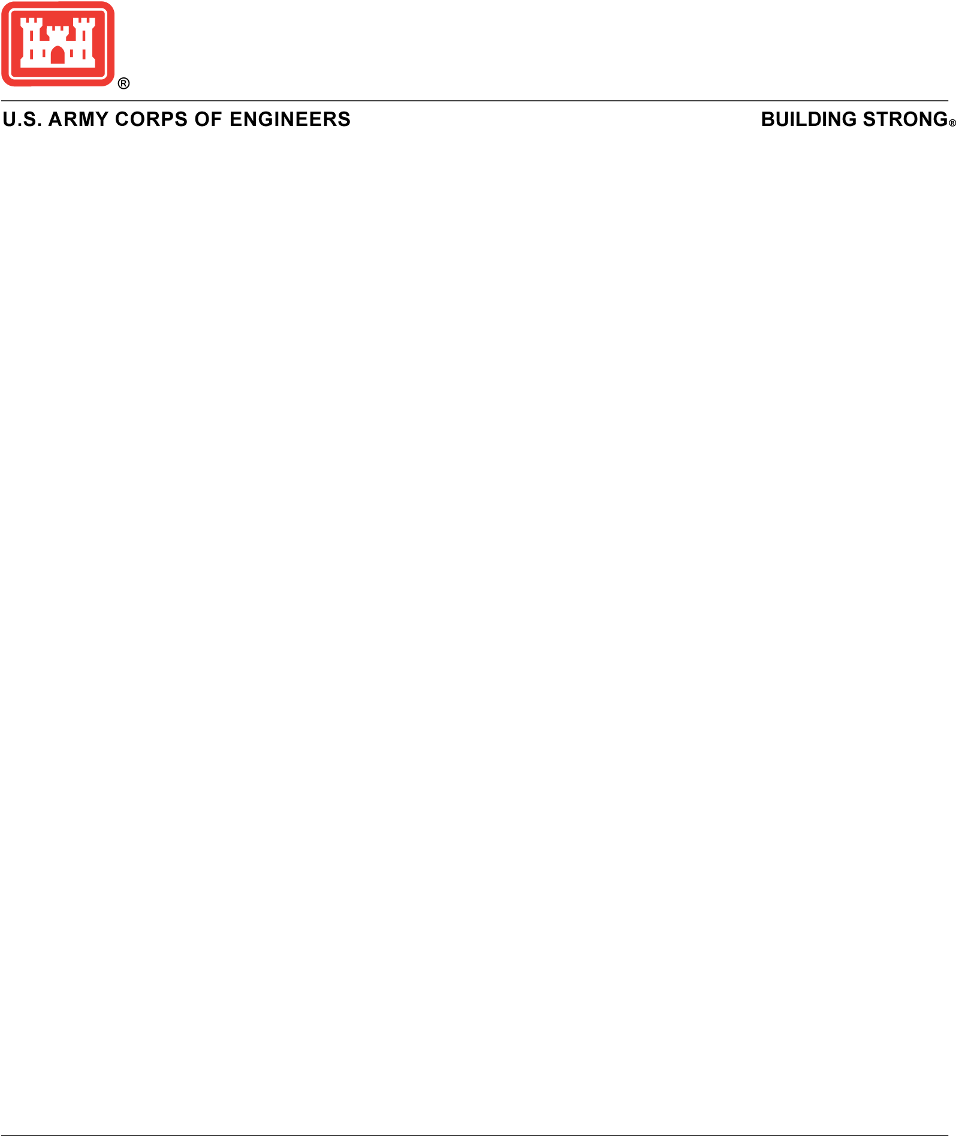­

Contact:

Steve Rochette

[Stephen.Rochette@usace.army.mil](mailto:Stephen.Rochette@usace.army.mil)

## 

## USACE shares update on dredging schedule for Manasquan Inlet

PHILADELPHIA -- The U.S. Army Corps of Engineers (USACE) Philadelphia District shared an update regarding navigation at the Manasquan Inlet in New Jersey.

In response to rapid shoaling on the inside of the inlet’s south jetty, USACE completed hydrographic surveys on Aug. 6, 2024. These surveys have been shared with the U.S. Coast Guard and [are available to mariners on the USACE webpage.](https://www.nap.usace.army.mil/Missions/Civil-Works/Surveys/Projects/NJInlets/)

Additionally, the USACE Dredge MURDEN completed two cycles of dredging on Aug. 6, 2024. The MURDEN will continue dredging when weather/sea conditions allow (likely on/around August 10, 2024). Work is expected to last 1-2 weeks.

“I’m grateful to the USACE Wilmington, New England, and New York Districts for their flexibility and re-arranging dredging operations at other locations to enable this work to move forward this weekend as opposed to later in the month when it was originally scheduled,” said USACE Philadelphia District Commander Lt. Col. Jeffrey Beeman. “I also want to thank our survey crews and the MURDEN crew for their efforts.”

It’s important to note that the Manasquan inlet is dynamic and conditions within the inlet can rapidly change. Significant shoaling has frequently occurred within the Inlet and often dissipates due to changing wind/wave conditions. Mariners should heed all warnings from the U.S. Coast Guard and proceed with caution.

Additionally, people should avoid walking/recreating on the unstable shoal given the dynamic nature of the inlet and sea conditions. The shoal is vulnerable to collapsing particularly after dredging operations.

The Dredge MURDEN is a 156-foot split-hull hopper dredge owned and operated by the USACE Wilmington District. It conducts dredging operations on numerous shallow draft channels and inlets along the East and Gulf Coasts of the United States.